School of Computer Science and Mathematics
6200COMP Project
Project Supervisor Form
This form should be signed (digital/image) by you and your supervisor and submitted to Canvas by Friday, 3 October 2025. It would help the overall process if you submitted as soon as you have agreed. Note that if you provide a project title in Section 2 this is not binding, it can be changed at any time. If you cannot find a supervisor complete the form by listing your subject interests in Section 3.
Do not hand in a hard copy. If your supervisor signs a hard copy, you need to scan it and upload it to Canvas.

- To be completed by all students
Name | Arwa Daaboul
Student ID# | 1036555
Programme | Computer Science

- Complete this section if you have found a supervisor
Project Title (or area) | Smart Habit Tracker
Supervisor | Dr Hoshang Kolivand

- Complete this section if you have not found a supervisor
My areas of interest are:

- Sign and Date
If you have found a supervisor, then they must sign the form.
Signature (student) | Arwa Daaboul | Date | 22/09/2025
Signature (supervisor) | 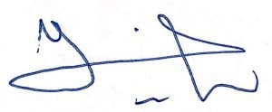 | Date | 22/09/2025

